May 30, 2019

ADDENDUM #1

To: Potential Bidders

RE: Rochester Housing Authority

P6 Porch Replacement Question

The second page indicates the location of the new concrete sidewalks. The areas in yellow, and
within the orange lines, indicate the areas that require new concrete.

Acknowledgement:

I have received the above referenced Addendum #1 and have used it in the
calculation/preparation of this bid.

___________________________________Contractor

Without acknowledgement of this addendum your bid may be non-responsive.

SCATTERED SITES PORCH REPLACEMENT QUESTIONS

1.) Question concerning the Two-Family Unit 382-384 Hawley Rear Demo Photos: notes states; REMOVE EXIST. CONC.WALK TO WALK AT SIDE OF HOUSE. My questioning, viewing the prints, I see the "New Concrete" stops at the end of the house for both sides, not continuing "alongside of the driveway side", or "alongside the other side".....according to the prints, if someone can please confirm, thanks.
Answer: The areas in yellow and orange are the extent of the new concrete sidewalk. The area in-between designated by the concrete symbol (stone-look) is the new overall concrete sidewalk.

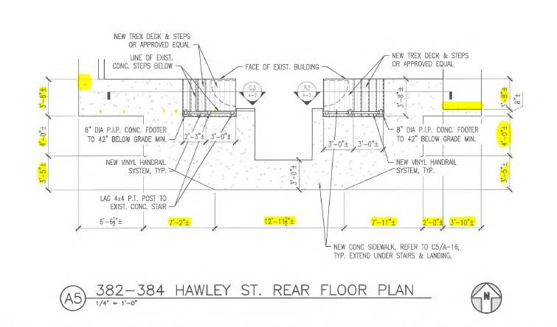

Front Porch Floor Plan

